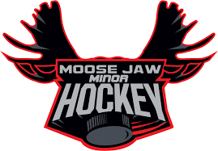

PROOF OF RESIDENCY

I / We, _________________________________________________________ parents or legal guardian(s) of __________________________________________________________________, currently reside at __________________________________________________________with the player named above. (Full residential address, or land location required. No box numbers.)
Signature of parent / legal guardian ______________________________________________________
Signature of parent / legal guardian ______________________________________________________
Contact________________________________ Date_______________________________________
PLEASE SIGN AND RETURN THIS FORM ALONG WITH SCANNED PDF’S OR PHOTO COPIES OF 2 OF THE FOLLOWING (no pictures please)
• a current utility bill in your name (must include service address as well as mailing address)
• proof of school enrollment (U7,U9,U11 & U13 only. Cannot accept for U15, U18)
• current GST statement or income tax assessment
• homeowner/rental insurance statement
• if moving prior to start of season - a signed purchase/rental agreement with possession date
• if moving to a home under construction – a signed builder agreement with possession date
Please note that property tax bills, cell phone bills, and driver’s licenses will NOT be accepted as proof of residency.

Moose Jaw Minor Hockey also requires a release from your previous Association, please include release with these documents

This form and the above listed documentation are required to ensure that Moose Jaw Minor Hockey is in accordance with SHA regulation 3.01.12 – 3.01.13 A bonafide resident is: A player who has moved with his/her parents and the parents have taken up physical residence by September 1st and continues to reside at said residence for the balance of the season.

Return Completed form and supporting documents to:
E-mail to admin@mjhockey.com

Moose Jaw Minor Hockey
370 Saskatchewan St W
Moose Jaw, SK S6H 2T2

